Part 1:

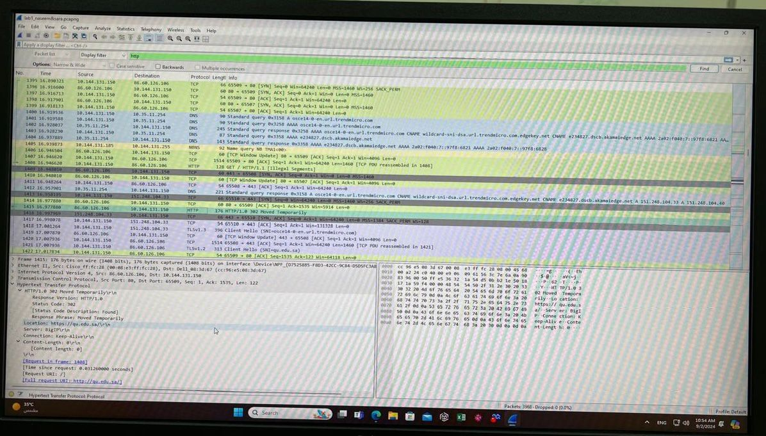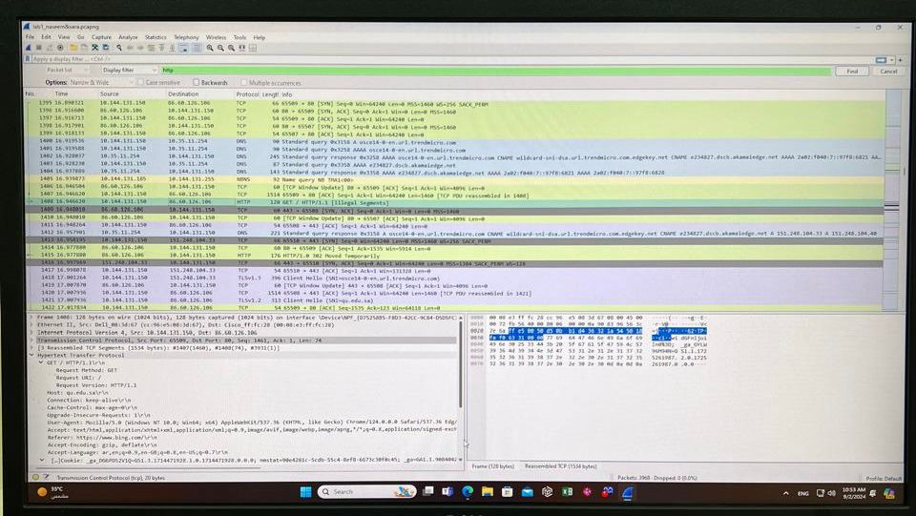

Part 2:

Part 3:

